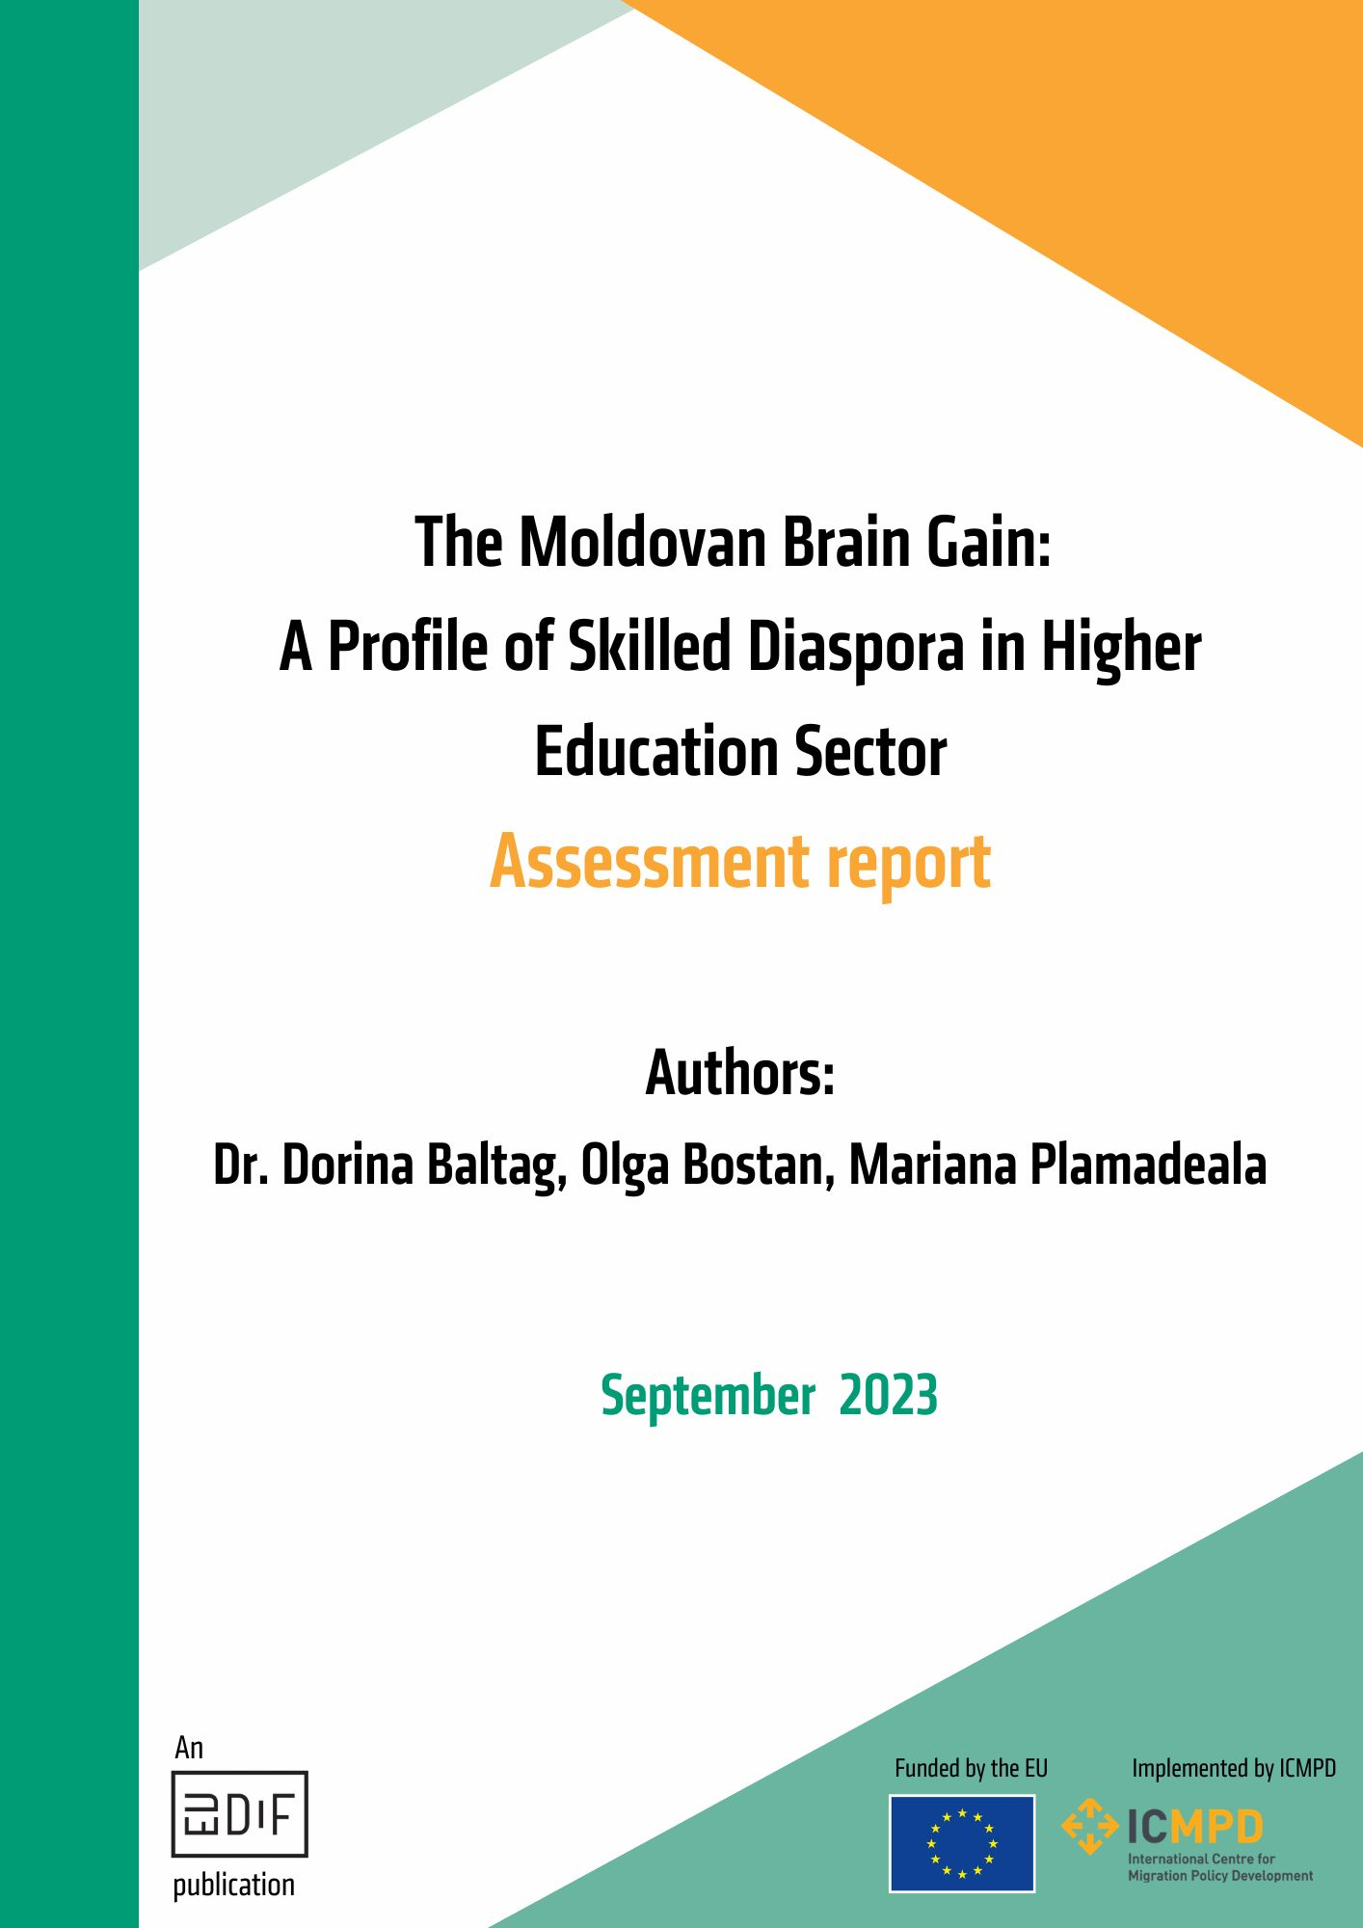

About the Project

This publication has been produced under the EU Global Diaspora Facility (EUDiF) as part of Diaspora Professionals for Development Mechanism to support the Moldovan Bureau for Relations with Diaspora over 2022 and 2023. The EUDiF Action has the objective to enhance the capacities of the Bureau to run a diaspora knowledge transfer scheme by piloting a methodology for the education and research sectors.

EUDiF is a pilot project funded by the European Union (EU) and implemented by the International Centre for Migration Policy Development (ICMPD). EUDiF strives to foster an informed, inclusive, and impactful diaspora-development ecosystem through knowledge and action, working together with partner countries, diaspora organisations in Europe, the EU, and its Member States.

The Bureau for Relations with Diaspora (BRD) is a directorate of the State Chancellery, under the direct subordination of the Prime Minister, which coordinates state policies in the field of diaspora engagement.

© – 2023 – ICMPD. All rights reserved. Licensed to the European Union under conditions.
This publication was funded by the European Union. Its contents are the sole responsibility of Dorina Baltag, Mariana Plamadeala and Olga Bostan and do not necessarily reflect the views of ICMPD nor the European Union.’

Table of Contents

About the Project 2
About the Authors 4
Abbreviations 5
Introduction 6
Section 1. Background overview 7
1.1. Policy Framework 7
1.2. Institutional Framework 8
1.2.1. National Stakeholders 8
1.2.2. International Stakeholders 9
1.3. Higher Education Framework 11
1.3.1. Higher Education Stakeholders 12
1.3.2. Higher Education and Diaspora 13
1.3.3. Higher Education Needs Categories 14
Section 2. Profiling Moldovan Highly Skilled Diaspora 16
2.1. Definition 16
2.2. Identifiers 17
2.3. Profile 18
2.3.1. Demographics 18
2.3.2. Migration Rationale 23
2.3.3. Expertise Transfer 24
2.3.4. Expertise Mobilization factors 26
Section 3. Engaging with the Diaspora: looking forward 33
3.1. Lessons Learned from Other Countries 33
3.2. From Data to Action 36

About the Authors
Dr. Dorina Baltag has gained over 12 years of professional experience working at universities in the Netherlands and United Kingdom, and currently holds a position as a postdoctoral researcher at the Institute for Diplomacy & International Governance at Loughborough University-London. Her areas of specialization include the EU democratization agenda, Eastern partnership countries, EU diplomacy, migration, and diaspora. Since 2013, Dorina has been an active member of the diaspora community, and as of 2020, she serves as the CEO of the Noroc Olanda Foundation, a Moldovan diaspora organization. Within the diaspora community, she shares her expertise on topics such as community development, problem-based learning, research for advocacy, and networking.
Olga Bostan is a junior researcher in the field of migration. In her role as a junior teaching fellow at University College Maastricht, she gained valuable professional experience teaching and designing courses in the field of sociology and cultural studies. She is currently advancing her expertise in anthropology at Leipzig University in Germany, with an academic interest in anthropology of infrastructure and anthropology of water. Olga has been an active part the Moldovan diaspora since 2014 and accumulated over 6 years of experience in community and project management as the Research and Development Officer at Noroc Olanda Foundation in the Netherlands.
Mariana Plamadeala holds an MSc in Quality Management Systems in France and has over 7 years of professional experience gained in France and the United Kingdom. Besides her activity as Quality Systems Engineer, Mariana has over 6 years in auditing processes in automotive field at European and global level. Her areas of specialisation are process mapping, continuous improvement, product and process ideation and implementation, customer and supplier management. From 2012 she initiated cultural diaspora activities in Strasbourg, France dedicated to the integration of Romanian speaking migrants. Since 2019, she founded the R.U.D.A NGO in the UK with the aim of reducing the stereotypes about the Romanian speaking community through social injustice issues, and cultural and networking activities as well as community-driven development.

Abbreviations

BRD | Bureau for Relations with Diaspora
CALM | Congress of Local Authorities from Moldova
DEH | Diaspora Engagement Hub
DMD | Diaspora, Migration and Development
DMDCM | Diaspora, Migration and Development Coordination Mechanism
EUDiF | European Union Global Diaspora Facility
HE | Higher Education
HTA  ICDMD | Hometown Associations  Inter-ministerial Committee on Diaspora, Migration, and Development
IOM | International Organisation for Migration
MIEUX+ | Migration EU Expertise
MER | Ministry of Education and Research
MiDL | Migration and Local Development Project
OECD | Organization for Economic Cooperation and Development
SDC | Swiss Agency for Development and Cooperation
UNDP | United Nations Development Programme
UNICEF | United Nations International Children's Emergency Fund

Introduction
For nations impacted by migration, such as the Republic of Moldova with one of the highest emigration rates globally, maximizing the potential of the diaspora beyond remittances is critical for the country's development. Different diaspora communities have varying potential for involvement that can benefit their countries of origin. Most recently, policymakers in Moldova view the diaspora as a key factor in driving positive changes in the field of higher education (HE).
Significant research investigating the contributions of the diaspora towards home country development has been conducted based on the example of diasporic communities worldwide. For instance, the members of African diaspora played a direct role on the economic growth of their countries of origin, particularly through the transfer of remittances. However, research has highlighted that the potential of the diaspora extends beyond individual remittances, and that the inflow of remittances in Western Balkans, for example, has affected the labour market by absorbing a significant local workforce.
Scholarship also shows that collective remittances can support philanthropic efforts. For example, diaspora philanthropy in the Philippines has emerged as a response to crisis and has resulted in the provision of valuable resources for problem-solving. Finally, a growing body of academic literature highlights the spill over effects of diaspora knowledge exchange and transfer of expertise to their countries of origin, turning brain drain into brain gain.
The purpose of this assessment report is to profile Moldova's highly skilled migrants connected to or interested in the HE sector. To profile Moldova's highly skilled diaspora, we collected data by conducting an online survey and interviews from August to December 2022. The report also offers an overview of Moldova's legislative and institutional framework for diaspora migration for development, the main goals of HE reform, and draws upon the experiences and lessons learned from other nations such as Armenia, Latvia, and Georgia in engaging with their diaspora.
The findings presented in this report provide a wealth of information crucial for making decisions about harnessing the human capital of the diaspora. It serves as: 1) foundations for policy evaluation and elaboration; 2) data repository; 3) an educational opportunity; and 4) a catalyst for action – a precursor to the creation of a Roadmap for stakeholders to connect with Moldova's highly skilled diaspora (see: Expertise Beyond Borders: Practical Roadmap on Piloting Diaspora Coworking Hub in the Higher Education in Moldova developed by the authors).

Section 1. Background overview

1.1. Policy Framework
For the past 20 years, Moldova has received support from international partners for the implementation of approximately 200 projects and programs related to migration, primarily aimed at regulating labour migration, and combating human trafficking. However, beginning in 2012, the focus of the legislative framework shifted towards maximizing the opportunities for developing relations with diaspora.
The Moldova 2020 Strategy, adopted in 2012, was the first document to incorporate migration and development into national policies. Other policies, such as the European Integration: Freedom, Democracy, Welfare government activity program (2013-2014), followed this policy direction and included diaspora as a governance objective, aiming to enhance communication with the diaspora, defend the rights and interests of Moldovan nationals abroad, and help develop and build the diaspora's civil society to maintain its ties with the nation.
Also in 2012, the creation of the Bureau for Relations with Diaspora (BRD) shifted the focus towards fostering greater dialogue with the Moldovan diaspora, coordinating government initiatives for the diaspora, and enhancing its contribution to the development of the country. Subsequently, in 2016, the National Strategy Diaspora-2025. This policy framework represents the first and primary initiative targeting the Moldovan diaspora directly. Its primary objective is to establish a sustainable and comprehensive framework of collaboration between state institutions and the diaspora based on trust and joint initiatives that facilitate productive return options for the diaspora.
To achieve the main objective, four sub-objectives were identified. One of them, objective 3, specifically focuses on mobilizing, utilizing, and recognizing the human potential of the diaspora, with priorities such as improving the capabilities of diaspora networks, communities, and associations; organizing activities to strengthen the diaspora (such as the Diaspora Congress and Diaspora Days); promoting charitable, philanthropic, and volunteer actions, as well as simplifying the process of validating academic and professional qualifications.
Finally, the government hosted a public consultation in August 2022 for the National Development Strategy Moldova 2030 . In this strategy, Moldovan diaspora is considered a key player in promoting the transfer of knowledge and skills through partnerships between local authorities, communities, diaspora, and hometown associations (HTAs). This policy document does not replace sectoral policies but highlights the sectors and priorities that are critical for Moldova's long-term sustainable development. It serves as the basis for all national, regional, and local policies and aligns with the UN's 2030 Agenda for Sustainable Development.

1.2. Institutional Framework

1.2.1. National Stakeholders
Moldova has developed a vast institutional framework to manage relations with diaspora and support the implementation of its policies. In this sense in 2017, Moldova approved the Diaspora, Migration and Development Coordination Mechanism (DMD CM) as part of its activity program for the Government (2016–2018). The purpose of this mechanism is to maximize the benefits of migration and minimize its negative consequences through effective policy implementation through, inter alia:
- coordinating and executing state policy on DMD by central and local public authorities.
- utilizing an integrated approach by local public authorities in the field of DMD locally and at a national level between ministries and central and local public administration.
To achieve such objectives, an Inter-ministerial Committee on Diaspora, Migration, and Development (ICDMD) was established. This Committee was set-up to oversee and coordinate the implementation of state policies in this field. It works to coordinate diaspora policy, establish its strategic vision, and ensure that programs and initiatives related to diaspora and migration are carried out effectively. The Committee is led by the Secretary-General of the Government and comprises representatives from key ministries and central administrative bodies. It meets every six months, as well as, when necessary, to keep its activities up-to-date.
At both the central and local levels, various state institutions are responsible for managing relations with the diaspora and harnessing Moldova's human capital. The primary stakeholder in this regard is the State Chancellery under the Prime Minister’s Office who houses the Bureau for Diaspora Relations (BRD). Furthermore, line ministries are supporting the government in achieving national policy objectives on diaspora, for example: the Ministry of Foreign Affairs and European Integration is tasked with providing consular services and protecting citizens overseas; the Ministry of Labour, and Social Protection deals with policies for diaspora return and reintegration; the Ministry of Education and Research (MER) covers all matters related to formal and non-formal education that also includes diaspora members. Finally, local townhalls coordinate and initiate the transformation of emigration into a chance for local development especially through the HTAs.

1.2.2. International Stakeholders
In addition to national actors, international development partners are supporting Moldova's DMD efforts. With the implementation of the Diaspora-2025 Strategy, the community of donors has been focusing its efforts on helping Moldova attract its human capital. The Table below presents some of the key international stakeholders that are contributing to creating a favourable environment for harnessing migrants' human and financial resources for the development of their home country.
Table 1: Moldova’s international development partners on DMD
Stakeholder | Framework of support
United Nations Development Programme (UNDP)-Moldova | Moldova was supported by the Migration and Local Development Project (MiDL) to develop an innovative partnership model at the local level, which leverages engagement of migrants towards hometown development. By 2018, the project had established 38 HTAs in its initial phase, serving as an institutional mechanism for involving migrants and the Moldovan diaspora in local development. With the support of over 100 HTAs and the Congress of Local Authorities from Moldova (CALM), the model has been successfully adopted and expanded to other locations.
Swiss Agency for Development and Cooperation (SDC) | The project Strengthening the Institutional Capacities of the Republic of Moldova in the Field of Migration and Development was funded by SDC to assist BRD in maximizing the positive impact of migration. This project has achieved significant outcomes, such as successfully implementing government programs that target the diaspora as beneficiaries, including the Diaspora Engagement Hub (DEH) Program, the Moldova - Making the Most of Migration multi-year program, and the NEXUS project. Additionally, the project supported the Republic of Moldova's associations and embassies in working with the diaspora.
International Organisation for Migration (IOM) - Moldova | IOM-Moldova enhances the capacity of Moldovan immigrant communities to actively engage in local development in their home country. The Migration and Development department focuses on helping the Moldovan government to maximize the benefits of diaspora resources for development and promoting the civic participation of the diaspora. Among the projects funded by IOM-Moldova are the Educational Centres and the Diaspora Excellence Groups, funded through the Engagement with Diaspora-Homeland Partnerships with the aim of enhancing the social, cultural and economic development of Moldova.
International Centre for Migration Policy Development (ICMPD) | ICMPD provides continuous support to the Moldovan government in addressing the impacts of emigration. Under a common initiative with the EU, MIEUX+, ICMPD assisted BRD in evaluating their National Strategy Diaspora 2025. Also, under another EU supported initiative, European Union Global Diaspora Facility (EUDiF), Moldova has received support from diaspora professionals through projects such as Promoting heritage tourism in Moldova through diaspora expertise and Piloting diaspora mobilization schemes in the education & research sectors in Moldova.
Source: Authors’ own compilation

1.3. Higher Education Framework
HE in Moldova is regulated by the Nomenclature of Fields of Professional Training and Specialties, a component of state education standards that determines fields and specialties for professional training. It is approved by the government, at the proposal of the Ministry of Education and Research, in consultation with other line ministries. In Moldova, universities have institutional autonomy, giving the university community the right to organize and manage, exercise academic freedom without interference, and assume competencies and obligations in line with national HE policies. University autonomy covers management, structure, teaching, research, administration, and funding.

The HE framework is guided by several policy documents, –under the umbrella of Education 2030 Development Strategy (2021-2030), aimed at improving education and rebuilding society's trust in HE. This builds on the Moldova 2020 Strategy within which the Higher Education Improvement Program Operations Manual was developed. The aim of the Programme is to support Moldova's strategies for European integration in science and research, and its commitment to reforming its HE system.
The HE framework is being reformed with several improvement steps taken. In June 2021, the National Action Plan on Quality Assurance of Higher Education was approved by the National Agency for Quality Assurance in Education and Research. In June 2022, MER announced a new development for the HE Reform aimed at modernizing universities and the research system through reorganization and absorption of certain HE institutions. The reform aims to raise educational standards, focus on the labour market, upgrade quality control systems, expand access to HE, improve university autonomy, enhance governance, and promote international cooperation.
This builds on the Higher Education Project Reform in Moldova, carried out by MER since September 2020, which aims to improve 3 areas: quality assurance mechanisms, labor market orientation through targeted interventions, and MER's project management capacity. The reform is funded by the International Development Association and World Bank.

1.3.1. Higher Education Stakeholders
The main HE stakeholder in Moldova is the Ministry of Education and Research (MER) and is supported by several other actors in the implementation of national policies presented in the Table below. In the area of engagement with diaspora, MER relies on the cooperation with other key DMD stakeholders including BRD, Ministry of Foreign Affairs and European Integration and other national and international actors.

TABLE 2: Higher Education stakeholders’ map
Stakeholder category | Name of stakeholder | Role of stakeholder
Key stakeholders directly responsible for policy-development in the field of education | Ministry of Education and Research of Moldova | the main public body responsible for developing and overseeing the implementation of policies in the field of education and research, is the main stakeholder in identifying the needs and opportunities of the educational sector.
 | Presidency of the Republic of Moldova, Advisor for Education and Research | has a structural overview of the educational initiatives that were and will be implemented in the country. Through the role of the advisors to the President can suggest changes for the educational ecosystem.
Supporting stakeholders involved in the implementation of policies in the field of education | HE Universities (e.g., Moldova State University; Academy of Economic Studies of Moldova; Ion Creangă State Pedagogical University etc.) | these actors represent higher-education institutions and are the main vehicles of implementing state policies on HE. Moreover, they engage in mobility schemes in the field of research and HE (e.g., Horizon Europe, Erasmus, and other independently established partnerships) that can also involve collaborations with diaspora professionals.
 | ANCD - National Agency for Research and Development | responsible for the implementation of state policies in the field of research, innovation, and development.
 | ANACEC- National Agency for Quality Assurance in Education and Research | to ensure and monitor the quality of services provided in vocational, higher, and continuing education and research, by providing an integrated system of external evaluation and accreditation of educational institutions.
 | Academy of Sciences | strategic consulting of the Government on policymaking in the field of applied research, having a vast history of engagement in the internationalization of education in Moldova, including through collaboration with diaspora professionals.
 | MOST - Moldovan Office for Science and Technology | to contribute to the advancement of the cooperation between Republic of Moldova and European Union in the field of Science and Technology. The stakeholder was involved in knowledge transfer mobilization schemes in the past, and key insights were collected for the development of the roadmap and the piloting phase of the project.
Source: Authors’ compilation

1.3.2. Higher Education and Diaspora
MER has invested work to address the needs of diaspora members returning to Moldova. In 2019, the Ministry approved two documents in this sense: 1) recognition and equivalence of study documents and qualifications obtained abroad, and 2) validation of non-formal and informal education. The latter was developed to provide a normative framework for identification, documentation, assessment, and certification of such learning. This tool formally recognizes the skills and abilities acquired non-formally by migrants abroad, aiding their successful reintegration into the local labour market.
The current HE framework does not specifically target diaspora involvement. Nonetheless, in August 2021, MER expressed willingness to collaborate with the diaspora during the 9th edition of Diaspora Days, with the goal of creating a platform for strengthening links between the Ministry, HE institutions, research organizations, and diaspora representatives. Moreover, the Minister emphasized the need to develop joint education and research projects and foster communication between academics in Moldova and in the diaspora. In May 2022, the first meeting between the Ministry and diaspora members took place, in which the latter consulted the Ministry on its initiative to establish a communication platform.

1.3.3. Higher Education Needs Categories
To consult national stakeholders in HE on diaspora engagement a fieldwork mission was conducted in August 2022 which revealed three categories of needs in HE and research: strengthening research collaborations, teaching modernization, and internationalization of the higher education.
For the first category, strengthening research collaborations, the focus is on engaging the diaspora in initiating and implementing joint research projects, organizing study visits, and hosting thematic events focused on research development, including developing joint research grants. Research requires access to European infrastructure, expertise, and financing. Interviewees suggested liaising with academic diaspora for accessing transnational academic networks that could foster the development of common research projects. There is also a need to advance research for evidence-based policymaking as well as integrate diaspora researchers as expert evaluators to ensure quality for international research projects.
In the second category, teaching modernization, the emphasis is on the need to shift from traditional Moldovan teaching methods (lectures and seminars that focus mainly on factual knowledge and are limited in applicative and analytic scope) to problem-based learning (PBL). Curriculum development was mentioned by stakeholders responsible for policy development and implementation in education; as well as by institutions supporting stakeholders involved in the implementation of policies in the field of education. For enhancing collaboration in teaching, it is important to attract diaspora members to share their teaching methodology practices in both a lecture and seminar setting. Also, modernization of teaching will benefit from further involving diaspora as expert evaluators for quality assurance.
The need in the third category, internationalization, is for an additional input in capacity building in the higher education sector as well as create an alternative voice for the development of the vision for research and development in Moldova. Interviewees stressed the need to develop partnerships between universities and/or other actors (start-ups, diaspora NGOs etc.), and initiate bids for funding for international higher education calls. To do so, the emphasis needs to be on capacity-building, which can be done, inter alia, through peer learning and personnel training with the contribution of diaspora members. Finally, job drain, and brain drain are the main issues that Moldova faces as there are almost no people capacitated with development skills to internationalisation indicators objectives. For Moldova to achieve its national development goals, it is imminent for science to become transversal to all policy areas in Moldova, which the Moldovan diaspora is familiar with.

Section 2. Profiling Moldovan Highly Skilled Diaspora

2.1. Definition
The migration of highly skilled individuals has been a topic of interest among public, policymakers and migration scholars since the 1960s. In the late 1990s, there was a shift away from focusing solely on economic remittances to considering “social remittances”, referring to the exchange of ideas, behaviours, practices, knowledge, and social capital between communities in sending and receiving countries.
The definition of highly skilled migrants can be both data-driven and policy-driven. Both approaches highlight the level of education or the classification of migrants' occupation as important criteria for identifying this group of migrants. Limiting the definition to education alone is restrictive. Hence, scholars acknowledge this specific group of migrants based on their “highly skilled job”, which is usually defined by the “possession of tertiary level education or equivalent experience”.
Many also use the definitions proposed by OECD studies, which combine educational background and occupation, including: “highly skilled specialists, independent executives and senior managers, specialized technicians or tradespeople, investors, businesspeople, 'keyworkers,' and sub-contract workers” . Therefore, the definition we use in this report incorporates both dimensions – educational background and their skills – thus separating the understanding of highly skilled migrants from their degrees and recognizing them also based on their abilities and job duties.

2.2. Identifiers
Based on the above conceptualization of highly skilled migrants, we use two criteria – education and competences – to identify Moldovan skilled diaspora for profiling.
Educational attainment
The first criterion for identifying Moldovan highly skilled diaspora is their educational attainment, which is understood as possessing tertiary education credentials (university-level education such as Master's degree, Doctoral degree, or Post-doctoral degree). This group is seen as a key part of the scientific and intellectual diaspora, who can play a crucial role as transnational actors in promoting education, science, technology, and socio-economic development in their home country.
Besides conceptualizing them as capable to facilitate individual and collective engagement, literature refers to this group as academics, highly talented individuals, or those with exceptional creativity. In addition to their academic talent, their type of occupation, such as researchers, scientists, scholars, or research managers, and the institutions they work in, such as universities or research institutes, line ministries or think tanks, are also relevant factors in their identification. This is because their work involves producing academic knowledge that may have commercial value.
Competences
Research highlights the fact that highly skilled professionals invest in their home countries by transferring their skills. Their motivation lies in the potential impact their knowledge and expertise can have on the development of their country of origin, rather than their connection to it through identity or sentiment. It's crucial to recognize that skills are a socially constructed concept that varies based on context and may be defined differently according to sectoral needs. That is why we use the term competences to refer to both knowledge and skills. We thus move away from seeing this as a criterion on “know-that” but rather as “know-how” – the ability to apply one's knowledge and skills to perform a task.

2.3. Profile
The survey profiling the Moldovan diaspora was conducted from August to November 2022 with the aim of mapping out their profile and identifying their experience with transferring their knowledge and skills. To corroborate the survey findings, interviews were conducted with several diaspora representatives at the beginning of December 2022. The survey targeted Moldovan highly skilled diaspora with university-level education and who were either working in universities or research institutes abroad, or were professionals with extensive work experience and relevant expertise for the development of education and research in Moldova. 100 respondents, all born in Moldova, were reached, representing three age categories: 31-35 (41%), 18-30 (26%), and 36+ (17%). The collected data on their experience with transferring know-how is also used to develop a practical Roadmap to mobilise diaspora (see: Expertise Beyond Borders: Practical Roadmap on Piloting Diaspora Coworking Hub in the Higher Education in Moldova developed by the authors).

Demographics
The survey revealed that respondents are distributed widely across three continents. The largest groups reside in the UK (22) and France (17), followed by countries in Europe such as Germany (6), Belgium (5), and Denmark (4), as well as the USA (4) and Canada (3) in North America. A small number of respondents reside in Africa (Somalia (1)) and Asia (Turkey (1), Qatar (1)). Additionally, 7% of respondents are part of the returning diaspora and currently reside in Moldova. The length of time spent abroad varies, with 41% residing abroad for 8 to 15 years, 26% for 4 to 7 years, and 21% for 15 to 20 years (see Figure 1).
Out of 100 Moldovan diaspora respondents, 20 have earned a PhD, 35 have a Master of Science degree, 12 have a Master of Arts degree, and 14 have a bachelor's degree. These degrees were mainly obtained from universities in France (16), the United Kingdom (16), Romania (7), the Netherlands (5), Belgium (4), Germany (4), and Denmark (2), with two earned in the USA. Importantly, 26 respondents obtained their educational degrees in Moldova. The main fields of study in the highest level of completed education are very diverse with Business management 7%; Political Sciences 6%; Medicine, neuroscience, physiology, human genome 5% as the “top” fields, followed by Chemistry, Law and international Law, General management, with 4% each.

Figure 1: How many years have you lived outside Moldova?
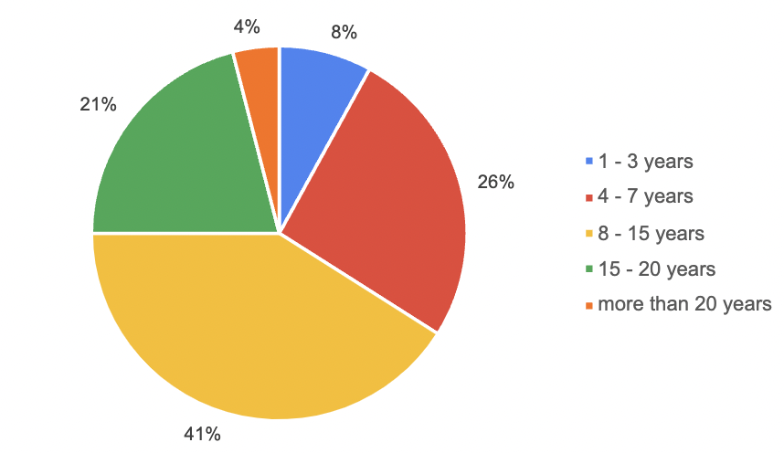

The vast majority (90%) of the Moldovan diaspora respondents are currently employed. As data in Figure 2 shows, 35% work in the private sector, 20% at a university or research institute, 16% are self-employed or offering consultancy services, 9% are company owners, and 7% work in the civil society sector. Under the “Other” percentage (10%) are public servants employed in various national agencies. The employment status of those who offered consultancy services to international organizations such as UNDP or UNICEF, is included in the 16% that represents independent workers.

Figure 2: Current employment status
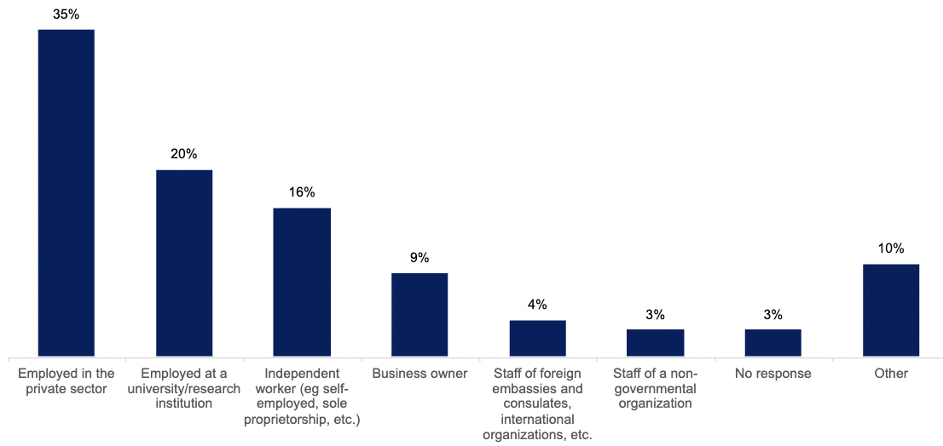
Figure 3: Number of years of work experience
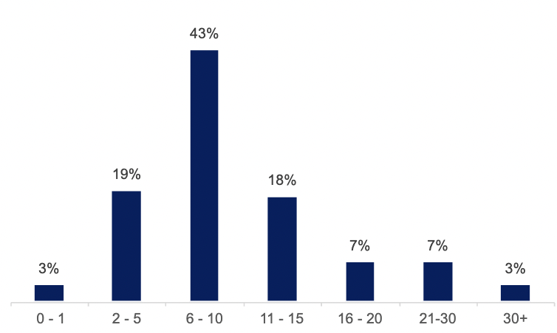

The total number of years of work experience of survey respondents varies from 1 to 30+ with the majority having acquired between 6 and 10 years (43%), as indicated in Figure 3.
The field of work of the respondents was complex to classify - among the 100 respondents, many of them reported they were active in multiple categories, listing 3 or even 4 different fields. They explained that while employed at a university, they could also work as part-time entrepreneurs, offer consultancy services as freelancers, or work on projects within a non-profit organization (including diaspora organisations). Figure 4 presents the current fields of work (as a percentage) based on the total 145 responses received as multiple-choice answers were applicable. The top two fields, by far, were: Administration, education, and healthcare (36.6%) and Professional, scientific, and technical services (44.8%).
Figure 4: Current field of work
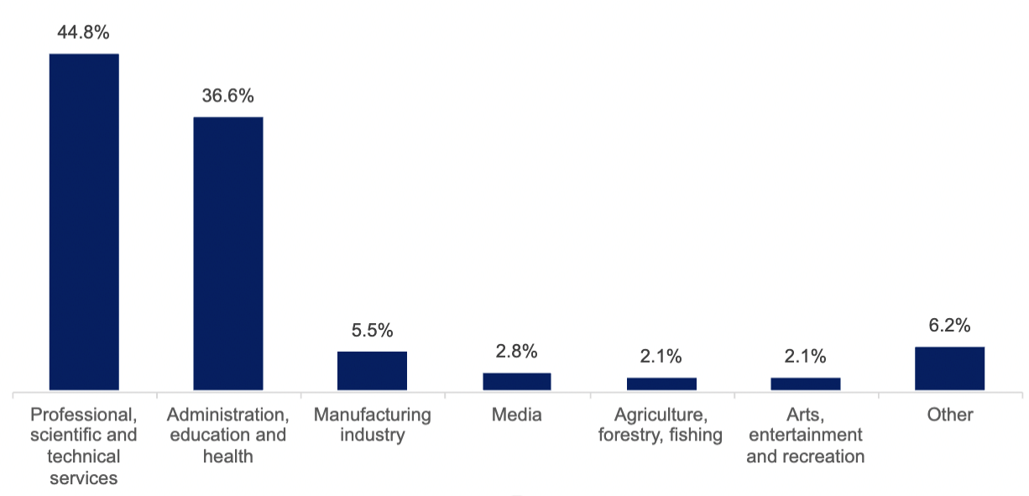

To gain insight into the primary areas of employment, we asked respondents to specify the distribution of jobs in Administration, Education, and Health as well as in Professional, Scientific, and Technical Services. As depicted in Figure 5, 42,9% work in Education and 41,3% are employed in the Public Health sector.
Figure 5: Top categories in the field of work - Administration, education and health
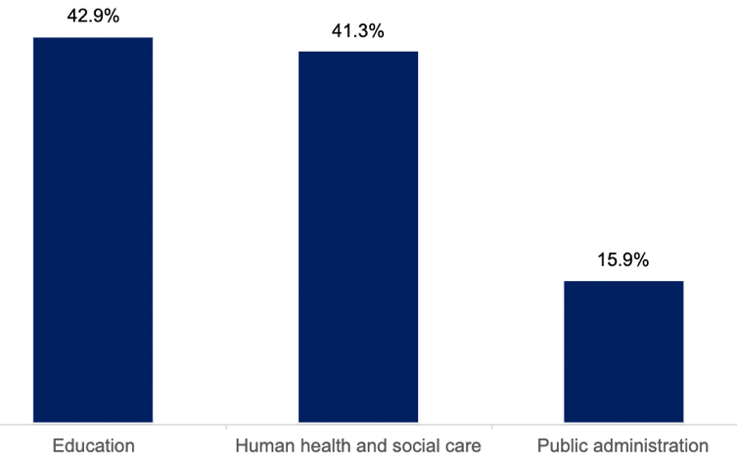

Figure 6 presents the top category “Professional, Scientific, and Technical Services” where 26% provide Research Services, 28% offer Consultancy Services.
Figure 6: Top categories in the field of work - Professional, Scientific, and Technical Services
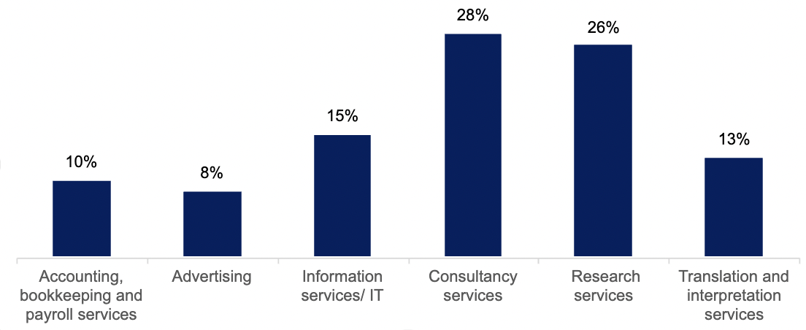

While 28% of respondents prefer not to share their annual income, 23% receive between €35,000-€49,999; 20% between €20,000-€34,999 with only 3% earning between €100,000-€149,999 (see Figure 7).
Figure 7: Annual income
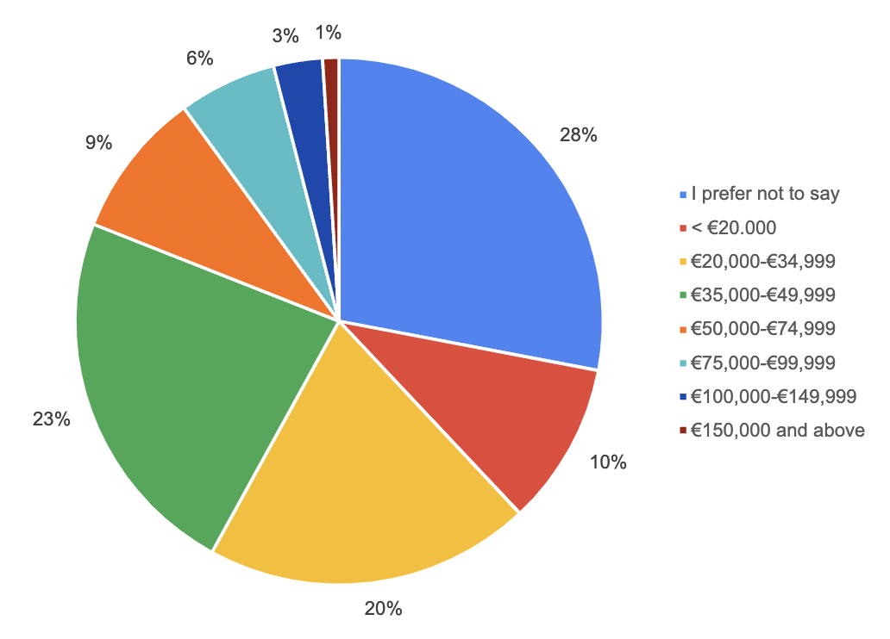
In terms of gender distribution, 70% of our respondents were female and 30% - male, and as such, women have a larger representation in most job categories. The data presented in Table 3 is calculated based on the respondents’ primary field of professional activity.
Table 3: Current field of work disaggregated by gender
Job category | % | Gender
Job category | % | Female | Male
Administration, education and health | 38% | 25% | 13%
Professional, scientific and technical services | 28% | 22% | 6%
Manufacturing | 5% | 2% | 3%
Media | 4% | 3% | 1%
Arts, entertainment, and recreation | 3% | 3% | --
Agriculture, forestry, fisheries | 3% | -- | 3%
Transportation | 3% | 3% | --
Other (financial and banking services, real estate, retail, logistics etc.) | 16% | 12% | 4%

Migration Rationale
When asked about their identity as a migrant, 42% of respondents identified as highly skilled migrants, while 17% identified as academic diaspora, and 26% did not identify as a migrant at all. Other responses included expatriate, digital nomad, knowledge migrant, student migrant, and global citizen.
The reason for migration for half of the respondents was seeking education opportunities (51%), while 25% cited economic reasons such as a higher salary, better job prospects, and improved living standards. Personal reasons like family reunification and personal development opportunities accounted for 15% (as shown in Figure 8). When asked about the main motivation to continue residing abroad, the majority of respondents (75%) cited economic reasons, followed by personal reasons (37%), education opportunities (36%), and political reasons such as safety and security (20%).
Figure 8: Main reason for moving abroad
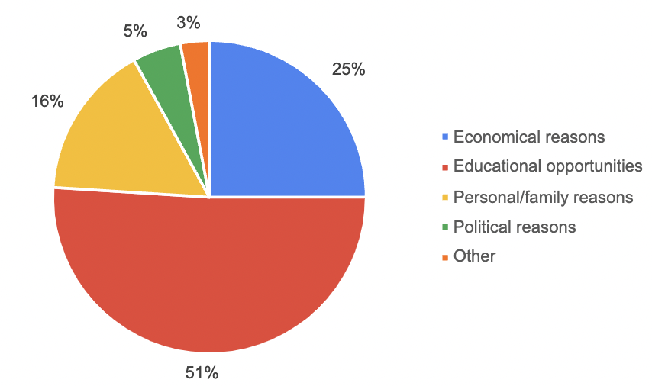
To corroborate these findings, we conducted interview discussions with 10 highly skilled Moldovan diaspora migrants with competencies in education and research. All of them emigrated in the pursuit of better educational and work opportunities and identify as highly skilled migrants. Irrespective of whether they hold a PhD or a MSc/MA degree, all of them share one important characteristic – they value the “hands-on approach” that their professional background and experience has provided them with, and it is this type of know-how that they share or intend to share with likeminded communities in their home countries.
Furthermore, these highly skilled Moldovan migrants share overlapping identifiers as defined by scholarship, namely they can be acknowledged in relation to a/the nature of their profession (international, interdisciplinary, multidisciplinary, in the realm of social sciences); b/channel or mechanism of migration (fellowship, scholarship, recruitment agents); c/mode of incorporation in the host country (neutral or advantageous); d/state of affairs in the country of origin (lack of economic opportunities, poor working and intellectual environments in the country of origin); e/length of stay in host country (permanent). As interviewees emphasized, these identifiers are extremely important to account for when engaging with them in view of making use of their intellectual capital.
Moreover, those who have obtained a degree abroad, indicated that among the main driving forces to do so, three were key: the opportunity to study and live in a multicultural environment (57%), the expectation to get a better employment (53%) and better research and education opportunities (52%).

Expertise Transfer
The Moldovan diaspora transfers its knowledge and skills through two avenues: by participating in the Moldovan diaspora community (such as within an organization, initiative group, or individually) or by sharing their expertise in a professional setting outside of their job requirements.

Figure 9: Form of diaspora collective Moldovans are members of
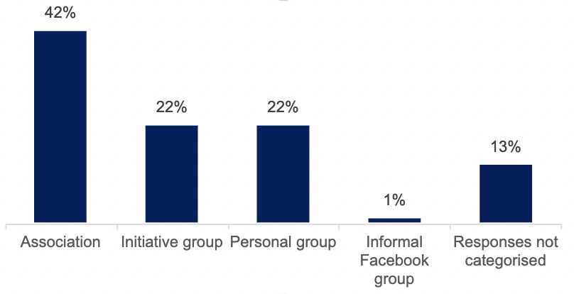

In the first avenue, involvement in diasporic communities, 57% of respondents indicated their membership in diaspora collectives. As shown in Figure 9, these take varying forms of organization, ranging from associations (e.g. foundation, NGO or any other legal form of registration) (42%), self-identified initiative groups without a legal registration (21.7%), personal groups (21.7%) and informal online communities such as Facebook groups (1%).
These collectives mainly activate in the social and cultural realm (44%), although they also conduct networking events (12%), charitable activities (12%), educational activities (6%), advocacy and lobbying actions (3%) and consultancy (2%), as shown in Figure 10. The majority of respondents (31,3%) declared a high level of involvement in ongoing activities organized by diaspora collectives, 25.4% of respondents declared a medium level of involvement and 23,9% a low one. A minority of respondents (6%) are members of a diaspora collective but are not involved in any of the activities they propose.
Figure 10: Diaspora Organisations’ domain of activity
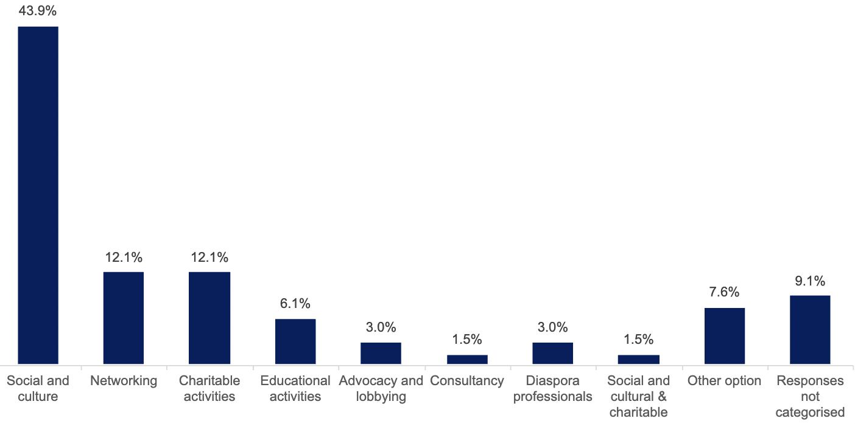

In the second avenue, involvement in professional activities, outside their job, 44% of respondents indicated that they have been involved in activities which involved the transfer of knowledge from their fields to various relevant stakeholders. The described activities can be generally categorized in four groups:
- teaching and research: these refer to collaborations between research and HE institutions in host and home country, as well as participation at international conferences and seminars;
- entrepreneurship: these refer to collaborations between diaspora members and representatives of the private sector (e.g., local entrepreneurs, companies and start-ups) through which mentorship and assistance was offered, targeting the economic and technological development of the country.
- partnerships with public authorities: these refer to collaborations between diaspora members and local public authorities, through which assistance and consulting is offered towards the advancement of democratic processes of the country, as well as the digitalization and improved transparency in state institutions.
- partnerships with NGOs: these refer to collaborations between diaspora members and local NGOs, that target the training and capacity building process of the local civil society and non-profit sector.

Expertise Mobilization factors
To harness Moldova’s highly skilled diaspora expertise it is important to be aware of the different factors that may influence the design of mobilisation schemes. To do so, we asked a series of questions to assess the respondents’ willingness to engage and the areas of engagement, as well as their position on the relationship between the development of the country and diaspora’s contribution with their knowledge and expertise.

Willingness to engage & return

Figure 11: Diaspora members planning to move back to Moldova for professional reasons
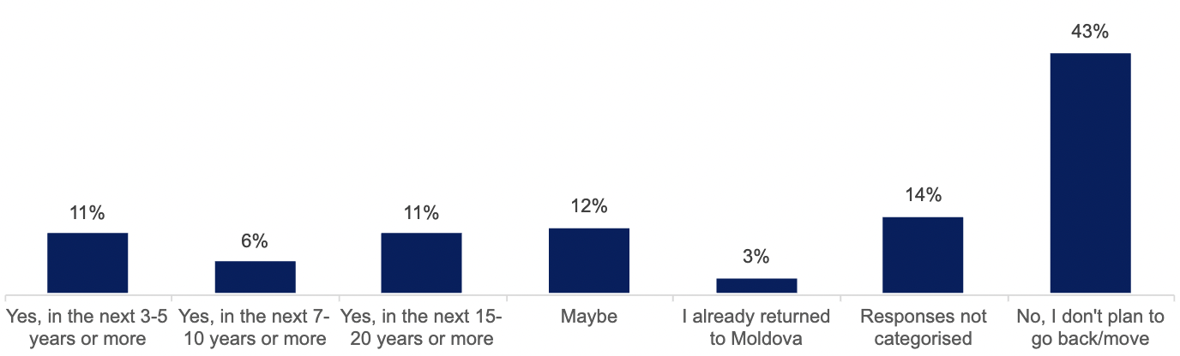
Most respondents (86%) are willing to engage and transfer their knowledge, skills, and expertise to institutions in their home country. The reasons not to engage, include limited time availability (37.5%) and job specifications that do not allow for involvement (12.5%). As Figure 11 shows a majority of respondents, 43%, do not plan to move back with only 11% planning to move back to Moldova for professional reasons in the next 3 to 5 years; and 11% in the next 15-20 years. We can deduce that most respondents willing to share their competences are interested by short or temporary schemes.

Importance of expertise transfer
Despite not being able or not planning to return, there is willingness to engage; and a vast majority of respondents consider that it is extremely important to transfer expertise, namely:
- 72% identified the economic development of the country as an extremely important area towards which the expertise of diaspora members should be channelled.
- for 65% of respondents, it is extremely important that the diaspora contribute to the political development of the country.
- 79% evaluate the importance of diaspora contributions towards the development of education and research as extremely important.
In Figure 12, the degrees of importance attributed by the respondents in relation to the economic and political development of the country and in education and research are represented on a scale from 1-5, where the numbers stand for the following options: 1-extremely unimportant, 2-unimportant, 3-neither important nor unimportant, 4- important, 5-extremely important.
Figure 12: Importance of Moldovan diaspora’ knowledge and expertise contribution
the economic development of the country
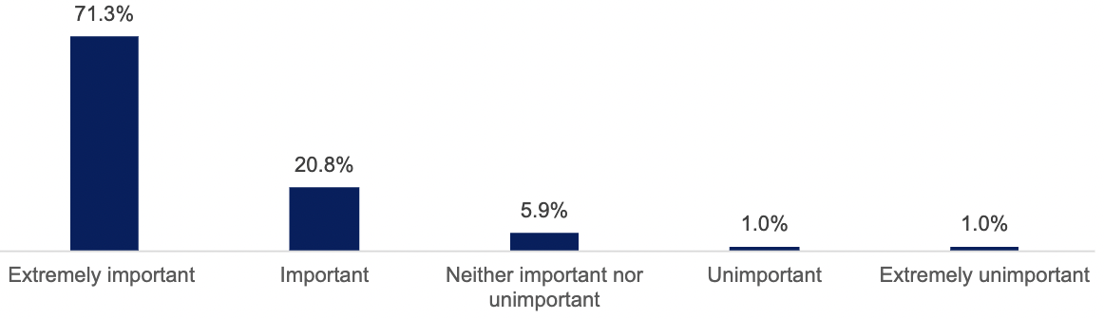
the political development of the country
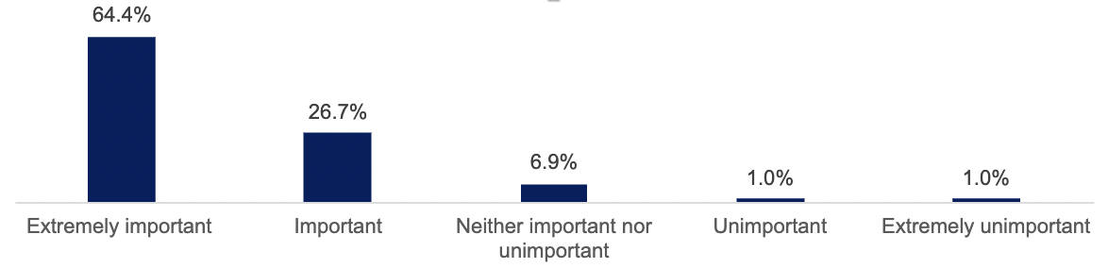
education and research development of the country
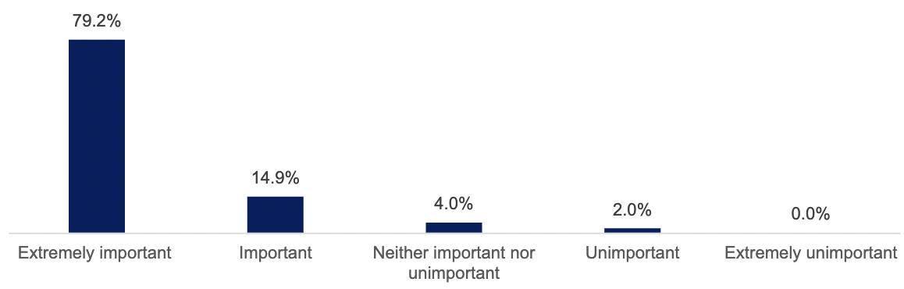

Level of satisfaction
Figure 13: Level of satisfaction of skilled diaspora vis-à-vis current level of engagement of Moldovan diaspora
the economic development of the country
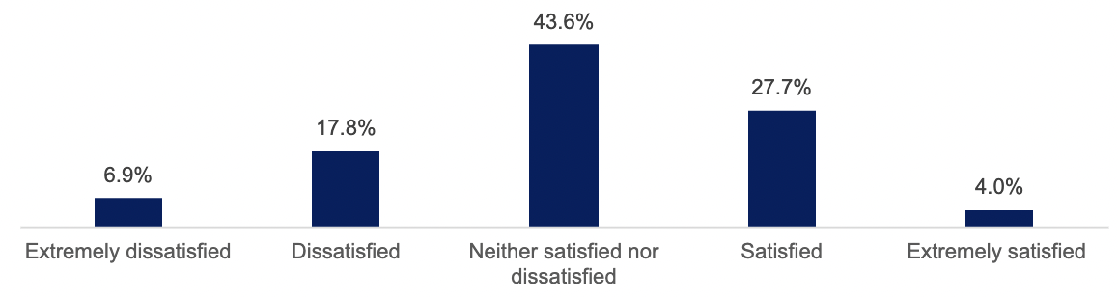
the political development of the country
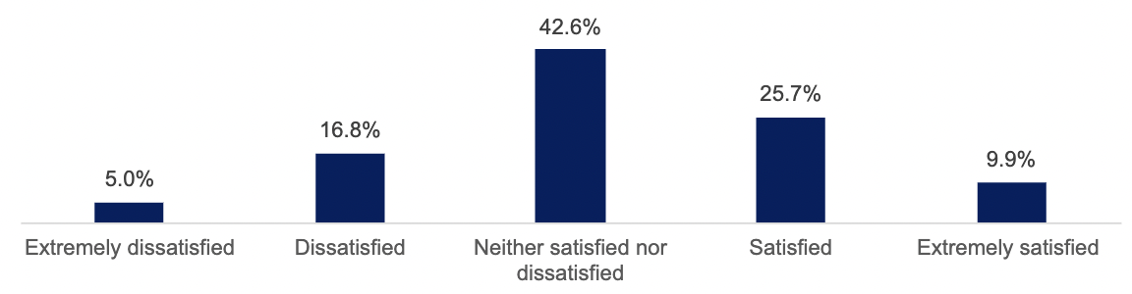
education and research development of the country
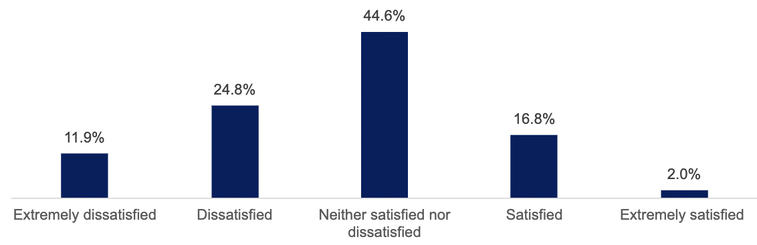
Assessing the current level of engagement of Moldovan diaspora in the economic and political development of the country and in education and research, opinion varied, as indicated in Figure 13. The levels of satisfaction of respondents are represented on a scale from 1 to 5, where the numbers stand for the following options: 1-extremely dissatisfied, 2-dissatisfied, 3-neither satisfied nor dissatisfied, 4- satisfied, 5-extremely satisfied.
Data above shows that:
- regarding economic development, the majority (44%) indicated that they are neither satisfied nor dissatisfied with migrants’ contribution to it, while 18% of respondents are dissatisfied and 28% are satisfied with it.
- 17% of respondents were dissatisfied and 26% were satisfied with diaspora’s engagement in the political development of Moldova, while most respondents (43%) are neither satisfied nor dissatisfied;
- in education and research, the majority (45%) was neither satisfied nor dissatisfied, 25% of answers indicated a dissatisfaction and 17% indicated satisfaction with the levels of involvement.
Areas of expertise transfer for HE
According to interviewees, engaging with stakeholders in the areas of research, teaching, and capacity building is crucial in Moldova's HE. In the survey, respondents were asked to choose and indicate the forms of engagement where their knowledge, skills, and expertise is most valuable. Figure 14 shows that 46,8% of respondents chose research as the most valuable, followed by teaching at 16,2%, mentoring at 14,1%, consultancy at 13,1%, and attracting funds at 9,8%. The data presented is based on 396 cumulative responses from a multiple-choice question.
Figure 14: Perceived sectors of most valuable contribution
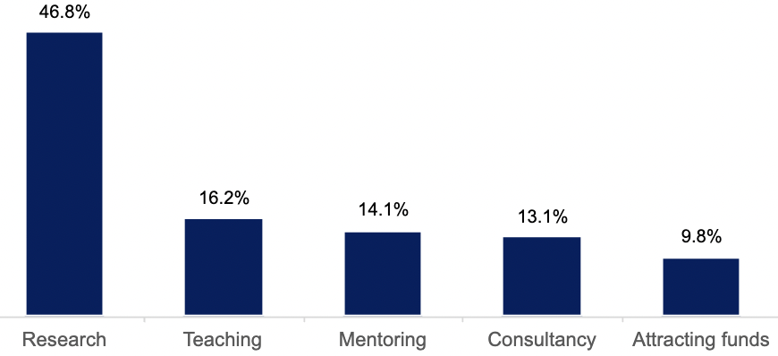

Familiarity with expertise-transfer mechanism in Moldova
Only 9% of respondents indicated awareness of such mechanisms referring to DEH programme, whereas 41% have no familiarity and 44% abstained from responding. Besides DEH, 2% mentioned the programs of expertise transfer set up by local HE institutions under the Francophone University Agency and another 2% indicated the activities organized by Diaspora Connect platform as expertise transfer mechanism.

Challenges & opportunities for skills transfer
According to the survey results, highly skilled diaspora are motivated to contribute to the development of their home country (36%) and to maintain a connection with their country of origin (24%). Such transfers of skills are also perceived as opportunities for professional development (20%) and networking with fellow professionals from Moldova (19%).
However, there are both opportunities and challenges in transferring know-how. The majority of respondents (46%) are willing to collaborate with local institutions remotely, offering up to 8 hours of their time weekly (showed in Figure 15). A significant number of respondents are interested in short-term (35%) visits, which provide an opportunity for knowledge exchange between the diaspora and their country of origin. Some of the “Other option” category suggest the hybrid model (online and short stays).
Figure 15: Conditions to participate in a skill transfer scheme
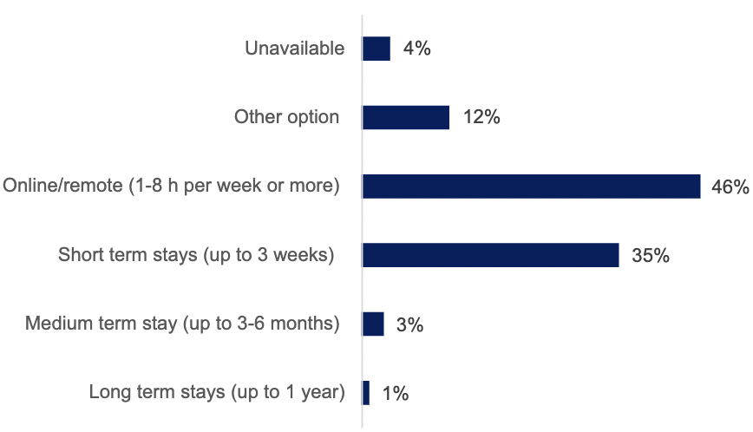

The lack of available resources (such as time and financial constraints) is perceived as the biggest challenge hindering migrants' involvement in expertise transfer schemes (31,8%). Other perceived challenges include the lack of openness from Moldovan institutions to collaborate (19,4%), the absence of a consolidated mechanism for expertise transfer (13,3%), and the absence of financial remuneration (9,5%) (see Figure 16).

Figure 16: Challenges to participation in skills transfer scheme
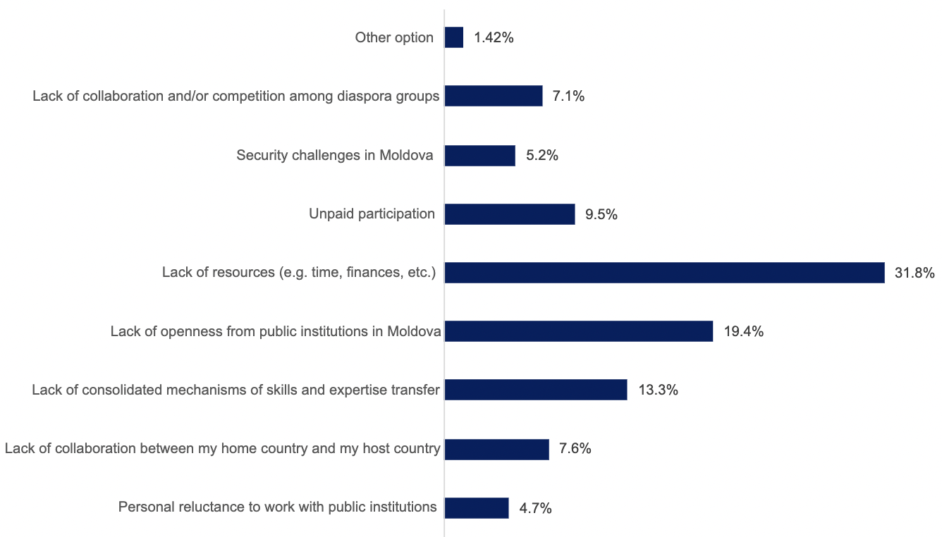
Moreover, the level of openness exhibited by Moldovan public institutions in engaging with the expertise of highly skilled migrants can influence their likelihood of engagement. Around 20% of respondents perceive Moldovan stakeholders as not open to collaborations, while 18% and 14% regard public institutions as open and extremely open for collaboration, respectively.

Section 3. Engaging with the Diaspora: looking forward

3.1. Lessons Learned from Other Countries
The literature highlights the crucial role that state, and state institutions play in transforming ‘brain drain’ into ‘brain gain’ through knowledge transfer between academic diaspora and educational institutions in their home countries. Effective policies that encourage circular mobility of skilled migrants and transnational professional networks can support local socio-economic development. To gain insights and practices relevant to Moldova for harnessing its diaspora human capital, this report looked at three countries - Latvia, Armenia, and Georgia - that share similar social capital score, a Soviet legacy in institutional practices, are affected by migration, and heavily rely on remittances for their economies. The table below summarizes the challenges these countries face in mobilizing highly skilled migrants for development.
Table 6: Key challenges for Armenian, Georgian and Latvian governments in mobilising highly skilled migrants
Challenge | Armenia | Georgia | Latvia
Policy | - lack of unified migration policy  - limited policy that targets diaspora engagement  - lack of policy framework to support reintegration | - lack of policies to attract back current migrants, especially highly skilled ones.  - little degree of policy alignment between HE and the labour market | - lack of unified policy targeting the professional integration of returned highly skilled migrants.
Institutional | - limited support is offered to promote reintegration.  - available information on migrants’ reintegration is distributed on the platforms of multiple governmental institutions, which is uncoordinated and not easily accessible | - little coordination on communication among governmental institutions regarding migration data and policy development.  - missing methodology for systemic registration of returned migrants (including gender and socioeconomic indicators) | - insufficiently promoted reintegration process by institutions.
Political | - given the political instability in the country, the levels of trust between the Armenian diaspora and the government are low. | - high numbers of outward migration in periods with political turmoil and internal instability, leading to demographic changes in the composition of the country’s population. | - highly politicized institutional discourse on Diaspora law conceptualization of migrants’ belonging
Diaspora | - the large numbers of diaspora organizations with different directions of interest lead to competing priorities among their representatives and overlapping competencies.  - scarce mapping data on diaspora structures is a further hindrance in the attempt to involve emigrants in the development of the country. | - the availability of migration-related data in Georgia is limited.  - systematic studies to understand thoroughly the relationship between migration and public policies have been scarcely conducted up to this moment. | - increasingly high numbers of Latvians choose to migrate, undergoing a process of rapid assimilation in the chosen destination countries.  - high numbers of outward migration among young people led to a change in the composition of Latvia’s population, expediting the process of demographic aging
Source: Authors’ own compilation
To effectively mobilize the highly skilled diaspora for HE, a crucial player in all three countries studied is the Ministry of Education. However, institutions responsible for diaspora affairs (such as BRD in Moldova) often take the lead in executing initiatives. To overcome the challenges presented above, each country has implemented successful programs and activities that can be seen as promising practices:
- in Armenia, the 2021 edition of the iGorts program resulted in 70% of highly skilled migrants deciding to repatriate. iGorts is a program which invites Diaspora Armenian professionals to serve in the public sector and the government of the Republic of Armenia. Additionally, the collaboration with highly skilled migrants in the field of health care proved to be an efficient crisis response through which the government supported diaspora’s contribution to their home country. Through the health program, highly skilled diaspora and the government collaborated on topics like: COVID-19, mental health and PTSD, physical therapy, and prosthetic (especially for wounded soldiers).
- in Georgia, the updated 2021-2030 Migration Strategy was prioritised on the political agenda of the government and aim to create a cohesive diaspora policy. The continuous activity of the State Commission on Migration Issues in promoting a unified set of actions to involve diaspora representatives is an example of sustainable practices. Several noteworthy efforts were initiated with the goal of highlighting the potential and contribution of highly skilled migrants to the growth of the Georgian state: Georgian Diaspora Forum, Georgian Diaspora Awards, the Global Conference for Diaspora Networks in Science.
- In Latvia, the development of a systematic framework for diaspora engagement and coordination, such as the Diaspora Law, ensures the sustainable contribution of the diaspora towards the development of the country. Assigning the role of liaising with the diaspora and representing their interest to a government official such as the Ambassador-at-Large for the Diaspora ensures an institutionalized channel of communication, collaboration with and inclusion in policy making of Latvians abroad. In addition, the purposeful targeting of highly skilled migrants from the field of science and education through thematic and networking events such as the World Congress of Latvian Scientists, contributes to harnessing the human capital of the country towards its economic, social, and cultural development.

3.2. From Data to Action
This assessment report serves as a catalyst for actions of engagement with highly skilled migrants. Its findings should serve as background information for developing an evidence-based roadmap on piloting diaspora mobilisation schemes.
Considering the widely acknowledged contribution that highly skilled migrants can bring towards the development of their countries of origin, evidence-based insights into the mechanism of expertise transfer can further the practical implementation of such schemes. In the case of Moldova, this report comes at a timely moment for achieving this goal, with both Moldovan diaspora representatives and Moldovan stakeholders declaring their openness and willingness to collaborate. Building on qualitative and quantitative findings, this report provides ample insights into the local and regional context of diaspora mobilisation which serve as factual recommendations for policymaking in the field of education and research.
Since the movement of highly skilled migrants is far from being new, a Roadmap for stakeholders to connect with Moldova's highly skilled diaspora (see Expertise Beyond Borders: Practical Roadmap on Piloting Diaspora Coworking Hub in the Higher Education in Moldova developed by the authors) should build on the findings presented here to show how to capitalize on Moldovan diaspora’s know-how. To do so, the roadmap will consider the policy and institutional framework, the sectoral needs for targeted expertise, and the profile of Moldovan highly skilled diaspora interested in exchange of knowledge and skills in the higher education and research sector. Finally, the variety of case examples can serve as a springboard for actions to be implemented by the members of such an exchange mechanism.
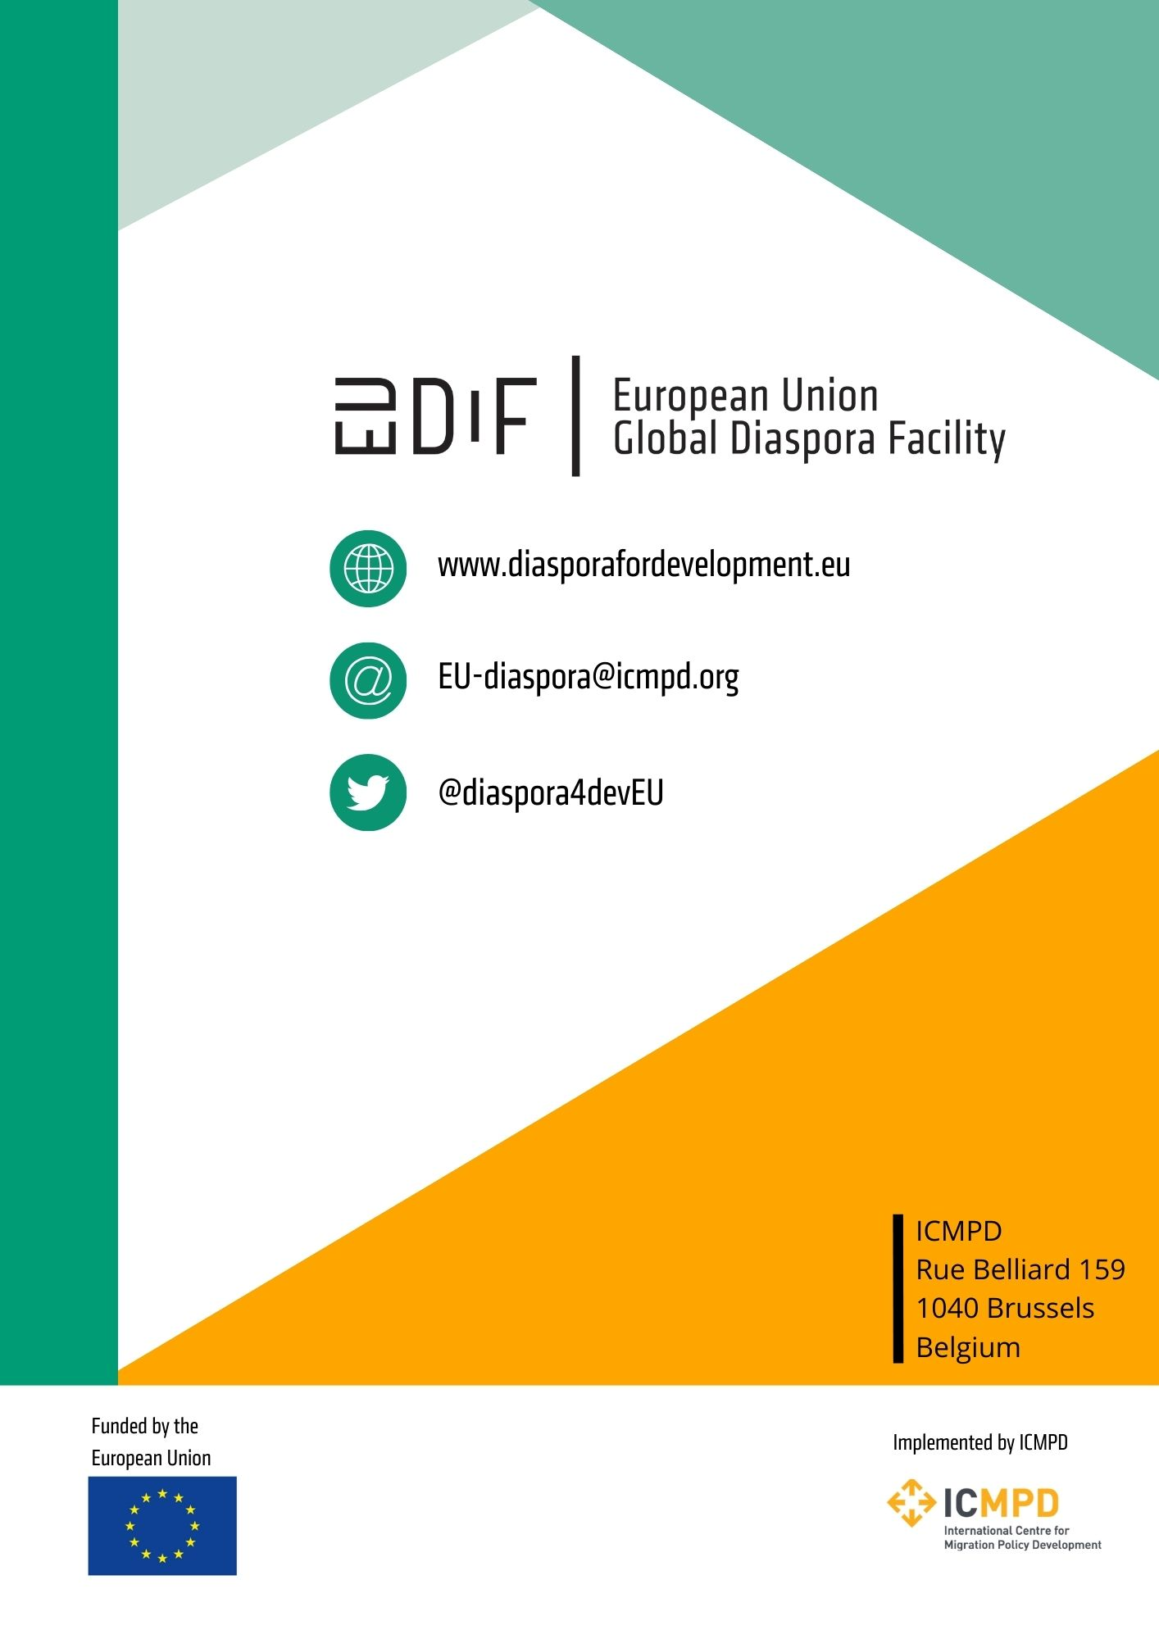

Data offered by United Nations (2022), available at: https://data.un.org/Data.aspx?d=PopDiv&f=variableID%3A85
Based on discussions held during our fact-finding mission to Moldova held from 17-21 August 2022.
See, inter alia, John, J. I., Orok, A. B., & Udoka, C. O. (2020). Migrant remittances and economic growth: The Nigerian perspective. International Journal of Scientific Engineering and Science, 4(1), 52-57; Mwangi, B. N., & Mwenda, S. N. (2015). The effect of international remittances on economic growth in Kenya. Microeconomics and Macroeconomics, 3(1), 15-24.
Topxhiu, R. M., & Krasniqi, F. X. (2017). The relevance of remittances in fostering economic growth in the West Balkan countries. Ekonomika, 96(2), 28-42.
Espinosa, S. A. (2016). Diaspora philanthropy: The making of a new development aid?. Migration and Development, 5(3), 361-377.
See, inter alia, Siar, S. (2014). Diaspora knowledge transfer as a development strategy for capturing the gains of skilled migration. Asian and Pacific Migration Journal, 23(3), 299-323; Welch, A. R., & Zhen, Z. (2008). Higher education and global talent flows: Brain drain, overseas Chinese intellectuals, and diasporic knowledge networks. Higher Education Policy, 21(4), 519-537.
IOM Moldova (2023). Projects completed towards human trafficking and protecting victims, available at: https://www.iom.int/preventing-trafficking-and-protecting-victims-moldova
The Government of the Republic of Moldova State Chancellery (2012). National Development Strategy „Moldova 2020”: Seven solutions for economic growth and poverty reduction (approved by Law nr. 166 of July 11th, 2012), available at: https://cancelaria.gov.md/sites/default/files/document/attachments/1100271_en_moldova_2020_e.pdf
The Government of the Republic of Moldova (2013). The Activity Program of the Government of the Republic of Moldova „European Integration: Freedom, Democracy, Welfare” 2013-2014), available at https://alegeri.md/images/d/d2/Program-activitate-guvern-moldova-2013-2014-ro.pdf
The Government of the Republic of Moldova (2012). Governmental Decision nr. 780 as of 19.10.2012, on the creation of BRD, available at: https://www.legis.md/cautare/getResults?doc_id=1682&lang=ro
The Government of the Republic of Moldova (2016). Governmental Decision nr. 200 as of 26.02.2016 on the approval of the National Strategy „Diaspora-2025” and the Action Plan for 2016-2018 for its implementation, available at: https://www.legis.md/cautare/getResults?doc_id=91207&lang=ro
The Government of the Republic of Moldova (2020). National Development Strategy 2030, available at: https://gov.md/sites/default/files/document/attachments/intr40_12_0.pdf
The Government of the Republic of Moldova (2017). Governmental Decision nr. 725 as of 08.09.2017 on the creation of the mechanism for the coordination and implementation of state policy in the field of diaspora, migration and development (DMD) by the central and local public authorities, available at: https://brd.gov.md/sites/default/files/document/attachments/hotarare_de_guvern_nr_725_2017.pdf
Ibidem
UNDP Moldova (2020). Engaging diasporas in local development: An operational guide based on the experience of Moldova, available at: https://www.undp.org/moldova/publications/engaging-diasporas-local-development-operational-guide-based-experience-moldova
Congress of Local Authorities from Moldova, available at: https://www.calm.md/
EDA (2023). Programs funded by SDC in Moldova, available at: https://www.eda.admin.ch/countries/moldova/en/home/international-cooperation/projects.html
BRD (2022). General information on Diaspora Engagement Hub (DEH) Program, available at: https://brd.gov.md/sites/default/files/document/attachments/informatie_generala_programul_deh_2022.pdf;
For a detail list of programs funded by IOM Moldova, please see: https://moldova.iom.int/finalized-projects; https://moldova.iom.int/enhancing-development-moldova-through-engagement-diaspora-homeland-partnerships-idf
MIEUX+ (2022). Moldova VII, available at: https://www.mieux-initiative.eu/en/actions/218-moldova-vii
EUDiF (2021). DP4D info sheet: Museum of Ethnography and Natural History in Moldova, available at: https://diasporafordevelopment.eu/library/dp4d-info-sheet-museum-of-ethnography-and-natural-history-in-moldova/
EUDiF (2022). DP4D info sheet: Bureau for Relations with Diaspora (BRD), available at: https://diasporafordevelopment.eu/library/dp4d-info-sheet-brd/
ANACEC (2021). National action plan on quality assurance of higher education in the Republic of Moldova for the period 2021-2023, available at: https://www.enqa.eu/wp-content/uploads/SEQA-ESG-national-action-plan_RM_Final_engl.pdf
MER (2023). The Elaboration of the Development Strategy for Education for 2021-2030 “Education 2030”, available at: https://mecc.gov.md/ro/node/10477
MER (2021). Moldova Higher Education Project. Higher Education improvement program operations manual (HEIPOM), available at: https://mecc.gov.md/sites/default/files/heipom_eng_p167790_final_approved_18.08.2021_wb.pdf
ANACEC (2021). National action plan on quality assurance of higher education in the Republic of Moldova for the period 2021-2023, available at: https://www.enqa.eu/wp-content/uploads/SEQA-ESG-national-action-plan_RM_Final_engl.pdf
MER (2022). Modern Universities for Sustainable Development, available at: https://mecc.gov.md/ro/content/universitati-moderne-pentru-o-dezvoltare-sustenabila
MER (2023). What you should know about the Higher Education Project Reform, available at: https://mec.gov.md/ro/content/ce-trebuie-sa-stii-despre-pism
World Bank (2022). Higher Education Project, available at: https://projects.worldbank.org/en/projects-operations/project-detail/P167790
ETF (2021). Skills and Migration Country Fiche Moldova, available at: https://www.etf.europa.eu/sites/default/files/2021-11/etf_skills_and_migration_country_fiche_moldova_2021_en_0.pdf
MER (2019). Order nr. 1702 as of 26.12.2019 on the recognition and equivalence of diplomas and qualifications obtained abroad, available at: https://mecc.gov.md/sites/default/files/ordin_1702_de_aprobare_a_regulamentului_de_recunoastere.pdf
IOM Moldova (2020). Practical Guidelines for the validation of competences acquired in non-formal and informal education contexts (levels 3, 4, 5 of the NCCRM), available at: https://moldova.iom.int/resources/practical-guidelines-validation-competences-acquired-non-formal-and-informal-education-contexts-levels-3-4-5-nccrm
BRD (2021). Report on Diaspora Days and Diaspora Congress, 9th edition, available at: https://brd.gov.md/sites/default/files/document/attachments/raport_zilele_diasporei_congres_2021.pdf
MER (2021). Education and research development issues discussed at the 9th Diaspora Congress, available at: https://mecc.gov.md/ro/content/aspecte-de-dezvoltare-educatiei-si-cercetarii-au-fost-discutate-cadrul-congresului-diasporei
BRD (2021). Report on the level of implementation of the Declaration of the Diaspora Congress, 2021 edition, available at : https://brd.gov.md/sites/default/files/document/attachments/raport_final_realizare_declaratie_congres_k.pdf
Köser-Akçapar, S. (2006). Do brains really go down the Drain? Highly skilled Turkish Migrants in the USA and the «Brain Drain» Debate in Turkey. Revue européenne des migrations internationales, 22(3), 79-107.
Levitt, P. (1998). Social remittances: Migration driven local-level forms of cultural diffusion. International migration review, 32(4), 926-948.
Docquier, F., & Marfouk, A. (2006). International migration by education attainment, 1990–2000. International migration, remittances and the brain drain, 151-199; Peri, G., & Sparber, C. (2011). Highly educated immigrants and native occupational choice. Industrial Relations: a journal of economy and society, 50(3), 385-411.
Bouvier, L. F., & Simcox, D. (1995). Foreign-born professionals in the United States. Population and Environment, 429-444; Libaers, D. (2014). Foreign‐Born Academic Scientists and Their Interactions with Industry: Implications for University Technology Commercialization and Corporate Innovation Management. Journal of Product Innovation Management, 31(2), 346-360.
Salt, J. (1997). International Movement of the Highly Skilled; OECD Occasional Paper No 3, 1997, p. 5.
OECD (1997). Trends in International Migration, Continuous Reporting System on Migration Annual Report 1996, OECD, Paris, p.21.
Tejada, G., Guerrero, G. T., & Bolay, J. C. (Eds.) (2010). Scientific diasporas as development partners: Skilled migrants from Colombia, India and South Africa in Switzerland: Empirical evidence and policy responses. Peter Lang.
Florida, R. (2008). Who’s your city? How Creative Economy is Making where to Live the Most Important Decision of Your Life. Basic Books, New York; Trippl, M., Maier, G. (2007): Knowledge Spillover Agents and Regional Development. Working Paper of DYNREG – Dynamic Regions in a Knowledge-Driven Global Economy Lessons and Policy Implications for the EU, Vienna.
Solimano, A. (Ed.). (2008). The international mobility of talent: Types, causes, and development impact. Oxford University Press on Demand.
in this study such evidence is presented based on the African example: Meyer, J. B., & Wattiaux, J. P. (2006). Diaspora knowledge networks: Vanishing doubts and increasing evidence. International Journal on Multicultural Societies, 8(1), 4-24
David, A. E. (2015). “Scientia est Potentia”: Human capital and the Role of Networks–Migration, Inclusion and New Qualification for a Sustainable Regional Economy. University of Twente.
Iredale (2001) as cited in Köser-Akçapar, S. (2006). Do brains really go down the drain? Highly skilled Turkish Migrants in the USA and the «Brain Drain» Debate in Turkey. Revue européenne des migrations internationales, 22(3), 79-107.
UTM (2023). Francophone University Agency, available at: https://utm.md/en/international-cooperation/francophone-university-agency/
Weinar, A., & Klekowski von Koppenfels, A. (2020). Highly-skilled migration: between settlement and mobility: IMISCOE short reader. Springer Nature.
Social capital score as of 2022 (100 being the ideal score) show - Moldova – 56,3; Georgia – 49,1; Armenia – 59,8; Latvia – 54. Solability (2022): Social Capital Index: World Map, available at: https://solability.com/the-global-sustainable-competitiveness-index/the-index/social-capital
International migrant stock data (number of international migrants) as of 2020 shows Moldova-104,4 thousand; Georgia-79,4 thousand; Armenia-190,3 thousand; Latvia-239,4 thousand: UN DESA (2020). Total number of international migrants at mid-year 2020, available at: https://www.migrationdataportal.org/international-data?i=stock_abs_&t=2020
Annual Remittance data in USD from 2021 indicates: Moldova - 2,085 mln - 15.2% GDP; Georgia – 2,644 mln – 14,1% GDP; Latvia – 1,317 mln – 3,4% GDP; Armenia – 1,610 mln -11,6% GDP: Knomad (2021). Remittances data, available at: https://www.knomad.org/data/remittances
Armenpress (2022). iGorts: 70% of second stage of program participants repatriated. Available at: https://armenpress.am/eng/news/1091621/
Office of High Commissioner for Diaspora Affairs (2023). Medical Support Program, available at: http://diaspora.gov.am/en/programs/33/health
State Commission on Migration Issues (2023). Migration Strategy, available at: https://migration.commission.ge/index.php?article_id=216&clang=1
Ministry of Foreign Affairs of Georgia (2019). Diaspora Forum 2019 has opened in Tbilisi, available at: https://mfa.gov.ge/News/diasporis-forumi-2019-dges-tematuri-shekhvedrebit.aspx?CatID=5&lang=en-US
Enigmma (2019). Georgian Diaspora Awards 2019, available at: http://www.enigmma.ge/news/georgian-diaspora-awards-2019/
IOM Georgia (2022). The Global Conference for Diaspora Networks in Science, available at: https://georgia.iom.int/news/global-conference-diaspora-networks-science
Ministry of Foreign Affairs of Republic of Latvia (2020). Latvia’s new Ambassador-at-Large for the Diaspora – Elita Gavele, available at: https://www.mfa.gov.lv/en/article/latvias-new-ambassador-large-diaspora-elita-gavele-0

